Nic Keller
Ultimate Cardio Football
Grade level(s): 9
Materials needed: Football(s), cones, pinnies, standard gymnasium or outdoor grass field, music (if available)
Purpose: To have the students work on football throwing and catching skills while working on cardiovascular fitness by continuously moving throughout the entire game.
Standards:
- ND State PE Standard 2- Students understand and apply movement concepts, principles, strategies, and tactics to learn and perform physical activities.
  - Benchmark 9.2.2- Apply intermediate biomechanical concepts that govern different types of movement (e.g., running on various surfaces, releasing a thrown object at different angles).
- ND State PE Standard 3- Students participate in regular physical activity.
  - Benchmark 9.3.1- Explain the long-term psychological (e.g., healthy self-image, improved confidence, stress reduction) benefits of physical activity.
- ND State PE Standard 5- Students exhibit responsible personal and social behavior in physical activity settings.
  - Benchmark 9.5.3- Explain appropriate behaviors (e.g., teamwork, tolerance, respect, compassion) while participating in group settings to achieve a common goal.
Objectives:
- The students will demonstrate the ability to release the ball at different angles to fit the distance needed to make the attempted pass.
- The students will list 3 long-term psychological benefits of physical activity (discussed at the beginning of class) at the end of the class.
- The students will demonstrate appropriate behaviors, such as teamwork and respect for others, throughout the entire class.
Learning activities:
- Discuss long-term psychological benefits of regular physical activity (i.e. healthy self-image, improved confidence, stress reduction). Ask students for other ideas of psychological benefits.
- The students will be broken into 2 teams (randomly selected by teacher).
- The rules are similar to ultimate frisbee rules:
  - When students have the ball they are only allowed to take two steps.
  - If the ball drops on the ground it is the defenders ball.
  - The team scores by making (at least) 4 passes and throwing into the end zone.
  - When teams are defending they are not allowed to make contact with the offense or strip the ball from an offensive player (3 foot buffer area between offensive player and defender).
  - Once the offense scores, the defense gets possession and becomes offense.
  - They are allowed to stand and block passes or knock the ball out of the air. They are trying to intercept passes and knock them down.
- Extra rules:
  - The students must keep feet moving (i.e. run, run in place, shuffle, etc.) the entire game.
  - Only allowed to stand still while holding the football.
  - Must make a pass within 5 seconds of getting possession of the ball or it will be considered a turnover and the defense will gain possession.
- Field Set-up:
  - Gymnasium: Out of bounds is the outermost line. Cones indicate front of end zone.
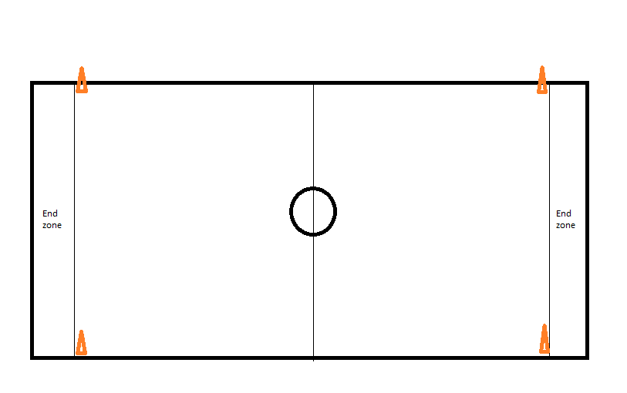
  - Outdoor field: Cones outline the end zones as well as the out of bounds lines. Dotted line represents imaginary lines connecting the cones.
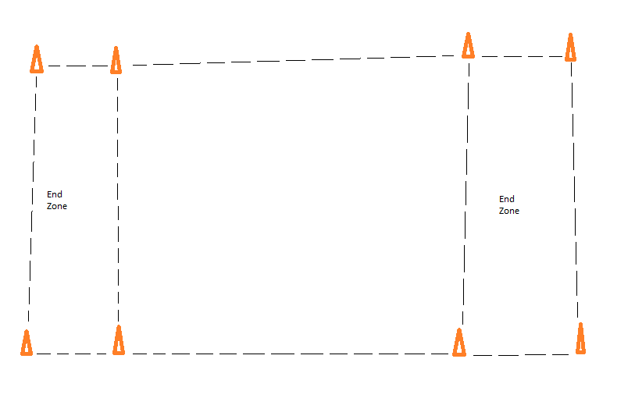
Assessment:
Name: _______________________________________ Date: ___________________
- Name at least three (3) positive long-term psychological benefits gained from participating in regular physical activity.
- Hypothesize (make and educated guess) as to why a person may gain these benefits from participating in regular physical activity.
Reflection: This lesson could be successful for a few reasons, first being that I believe the students would find it enjoyable and would be willing to participate fully in an activity that will get their heart rates up and provide cardiovascular benefits. Second, this lesson provides knowledge of long-term benefits rather than just having fun “right now” which may provoke that “aha!” moment for some students who do not understand why they should stay active. Third, the assessment helps re-enforce the knowledge that the students should have gained at the beginning of class. Rather than just hearing something, they are also writing it, giving them another opportunity to retain information.

